Name: Arpit Mahalle
User story screenshots
User Story 1:
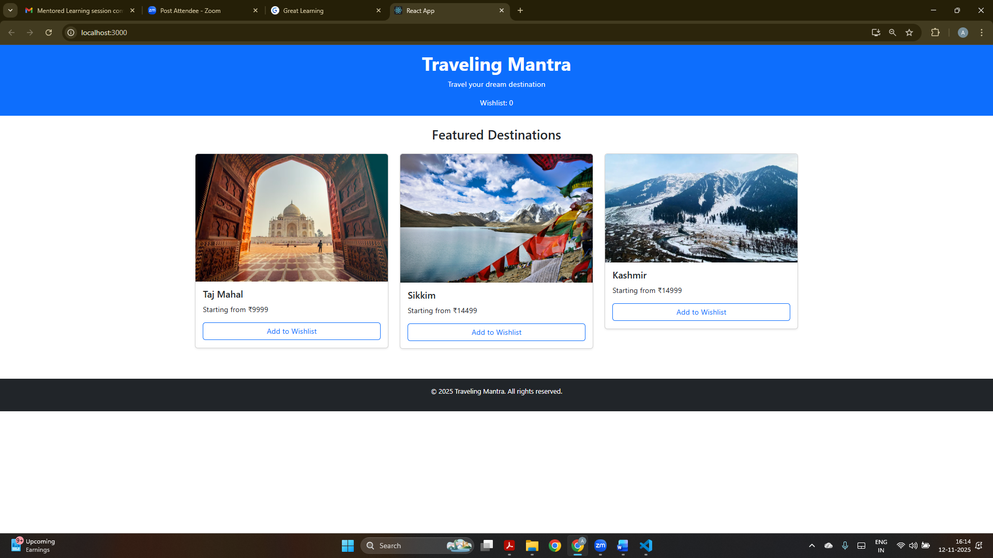
This is the home page of Traveling Mantra Travel Booking Application
Where tours are available.

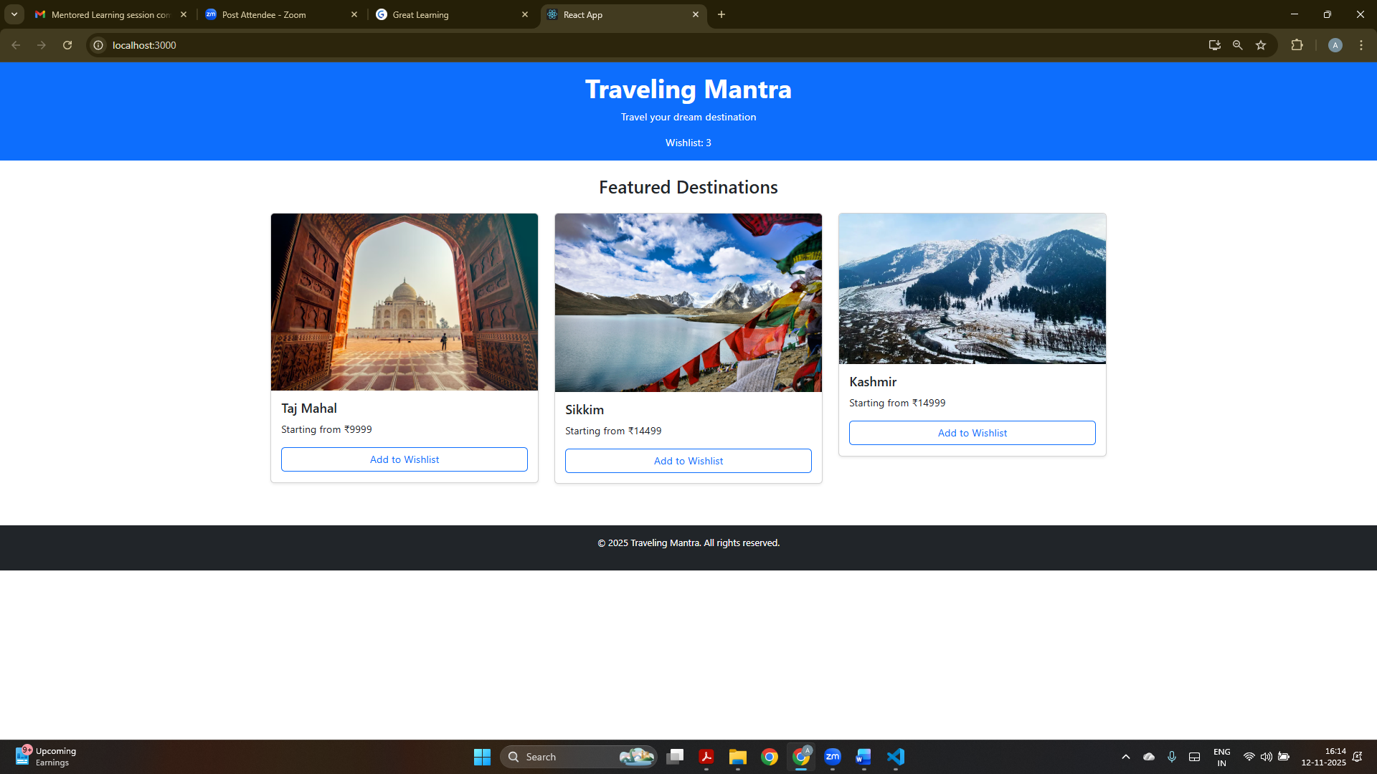
By clicking on “Add a wishlist” the wishlist count gets updated.

User Story 2:
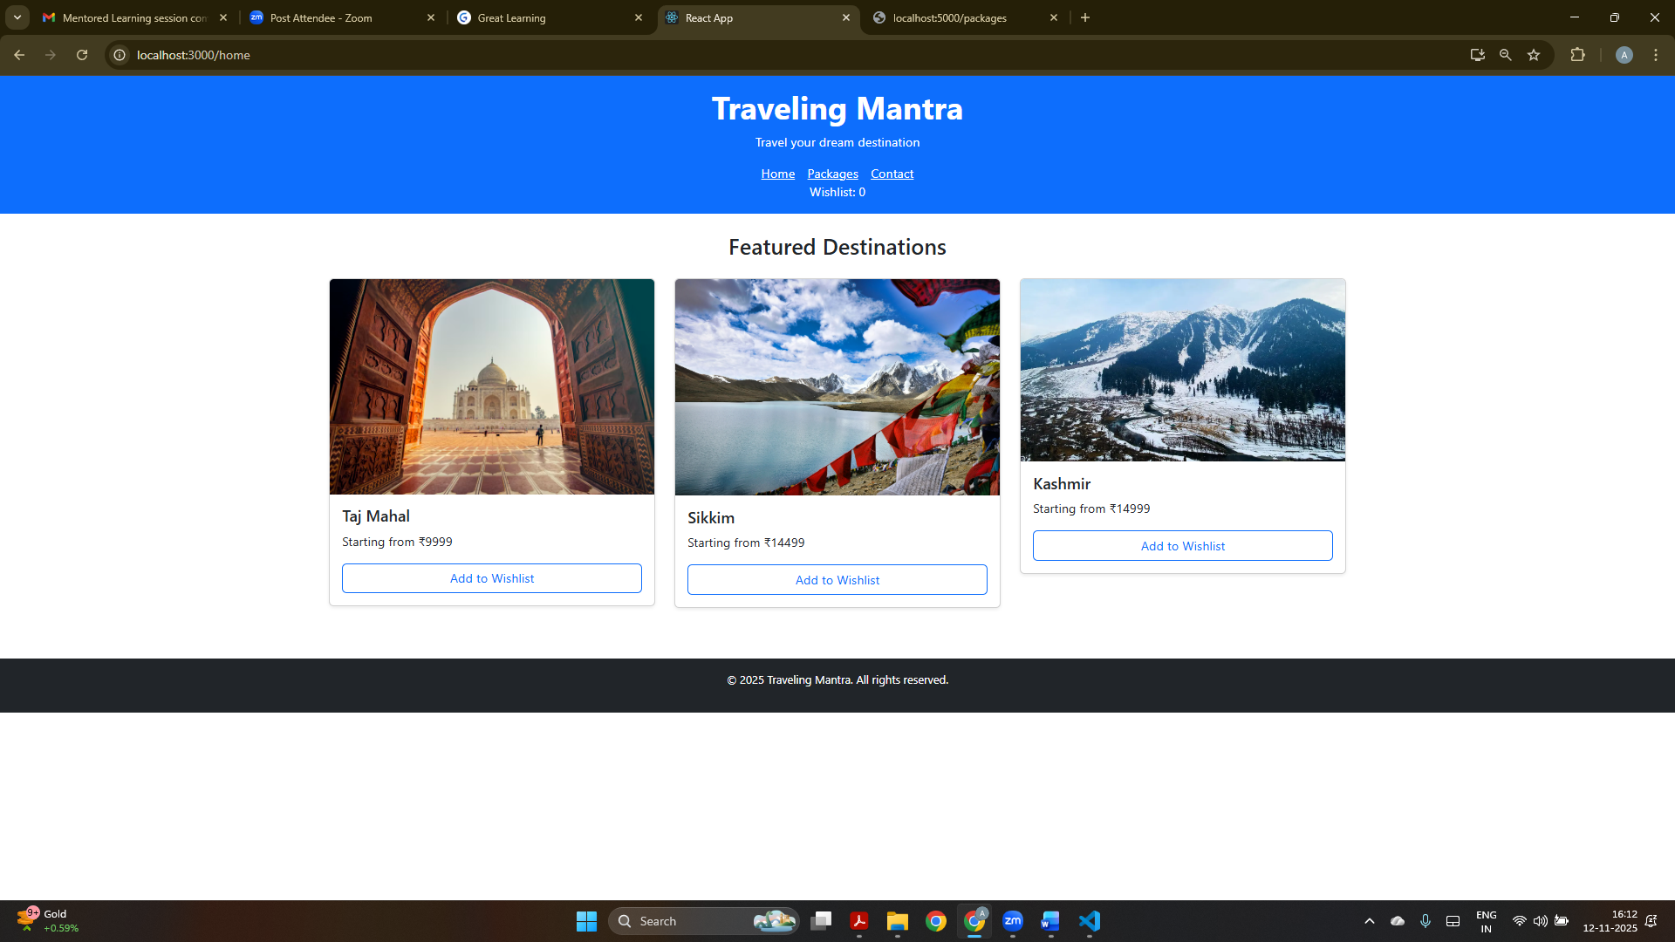
Here, we can navigate through Home, Packages and ContactUs.

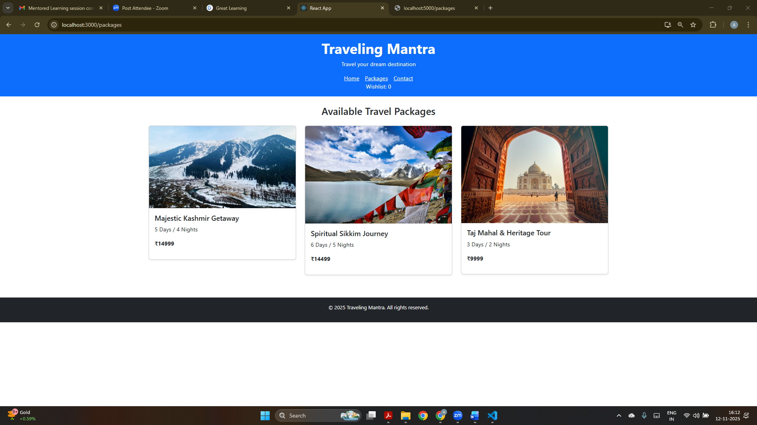
Thses are the available package in this travel booking application.

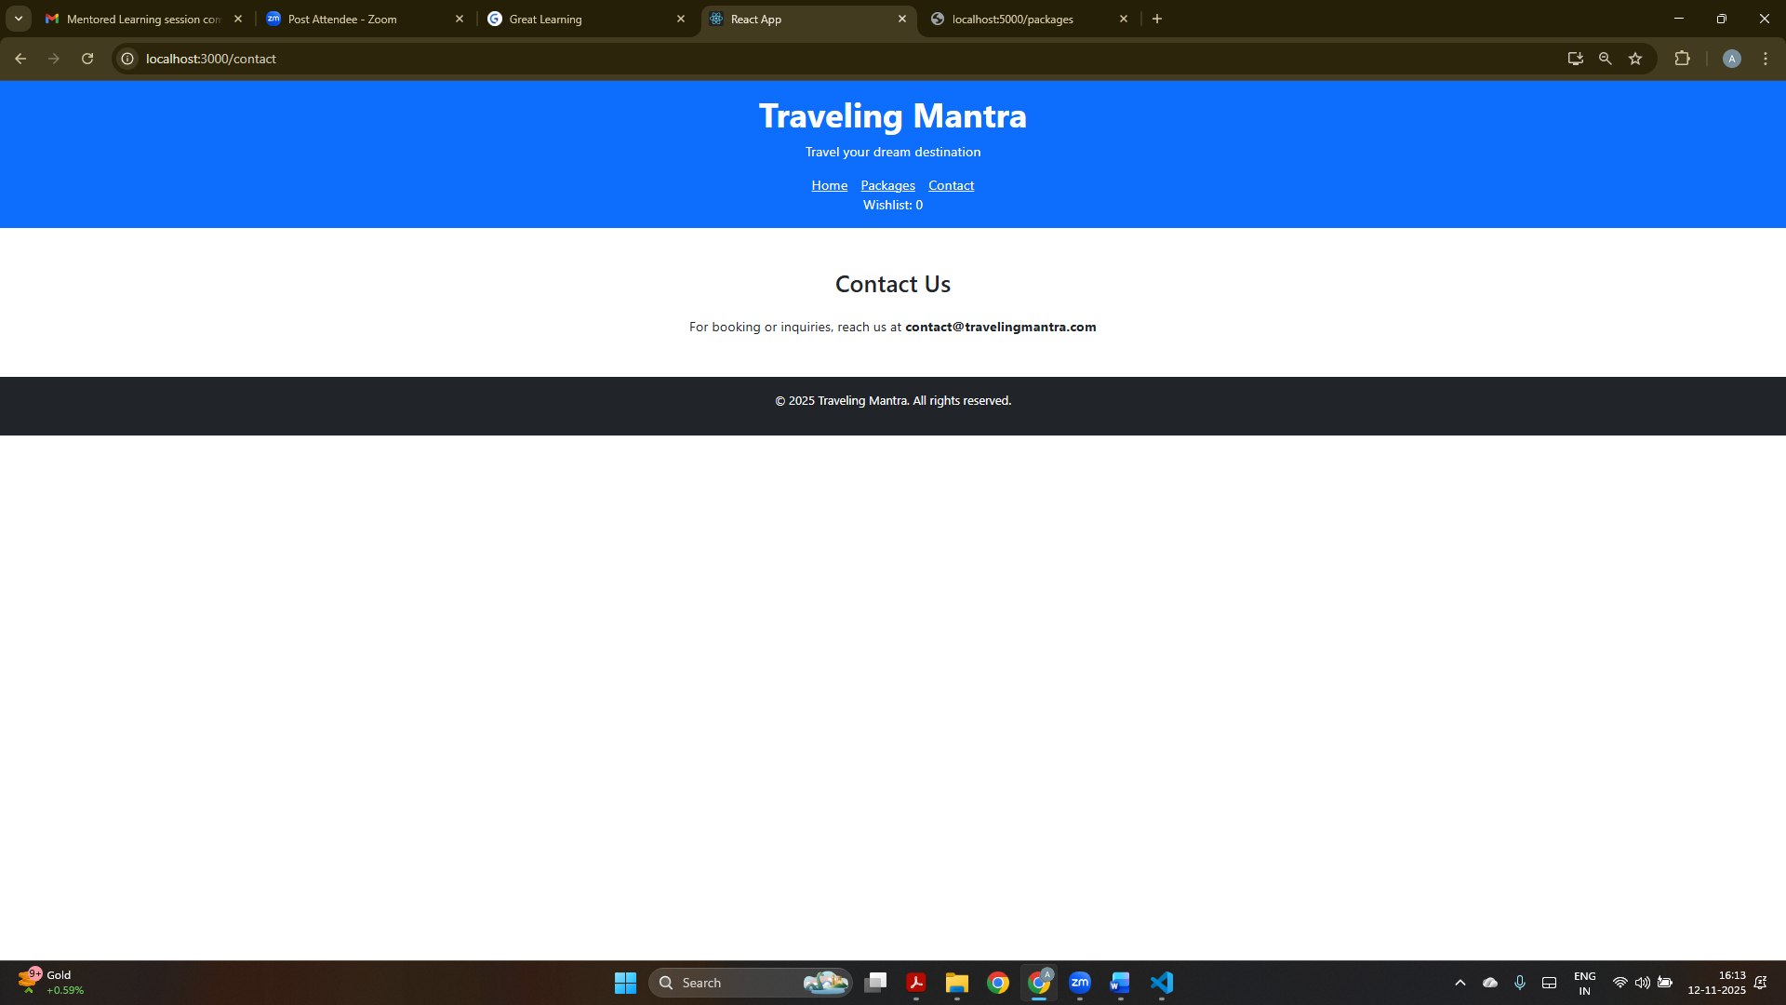
Here, a contact email is shared for enquiry of packages etc.

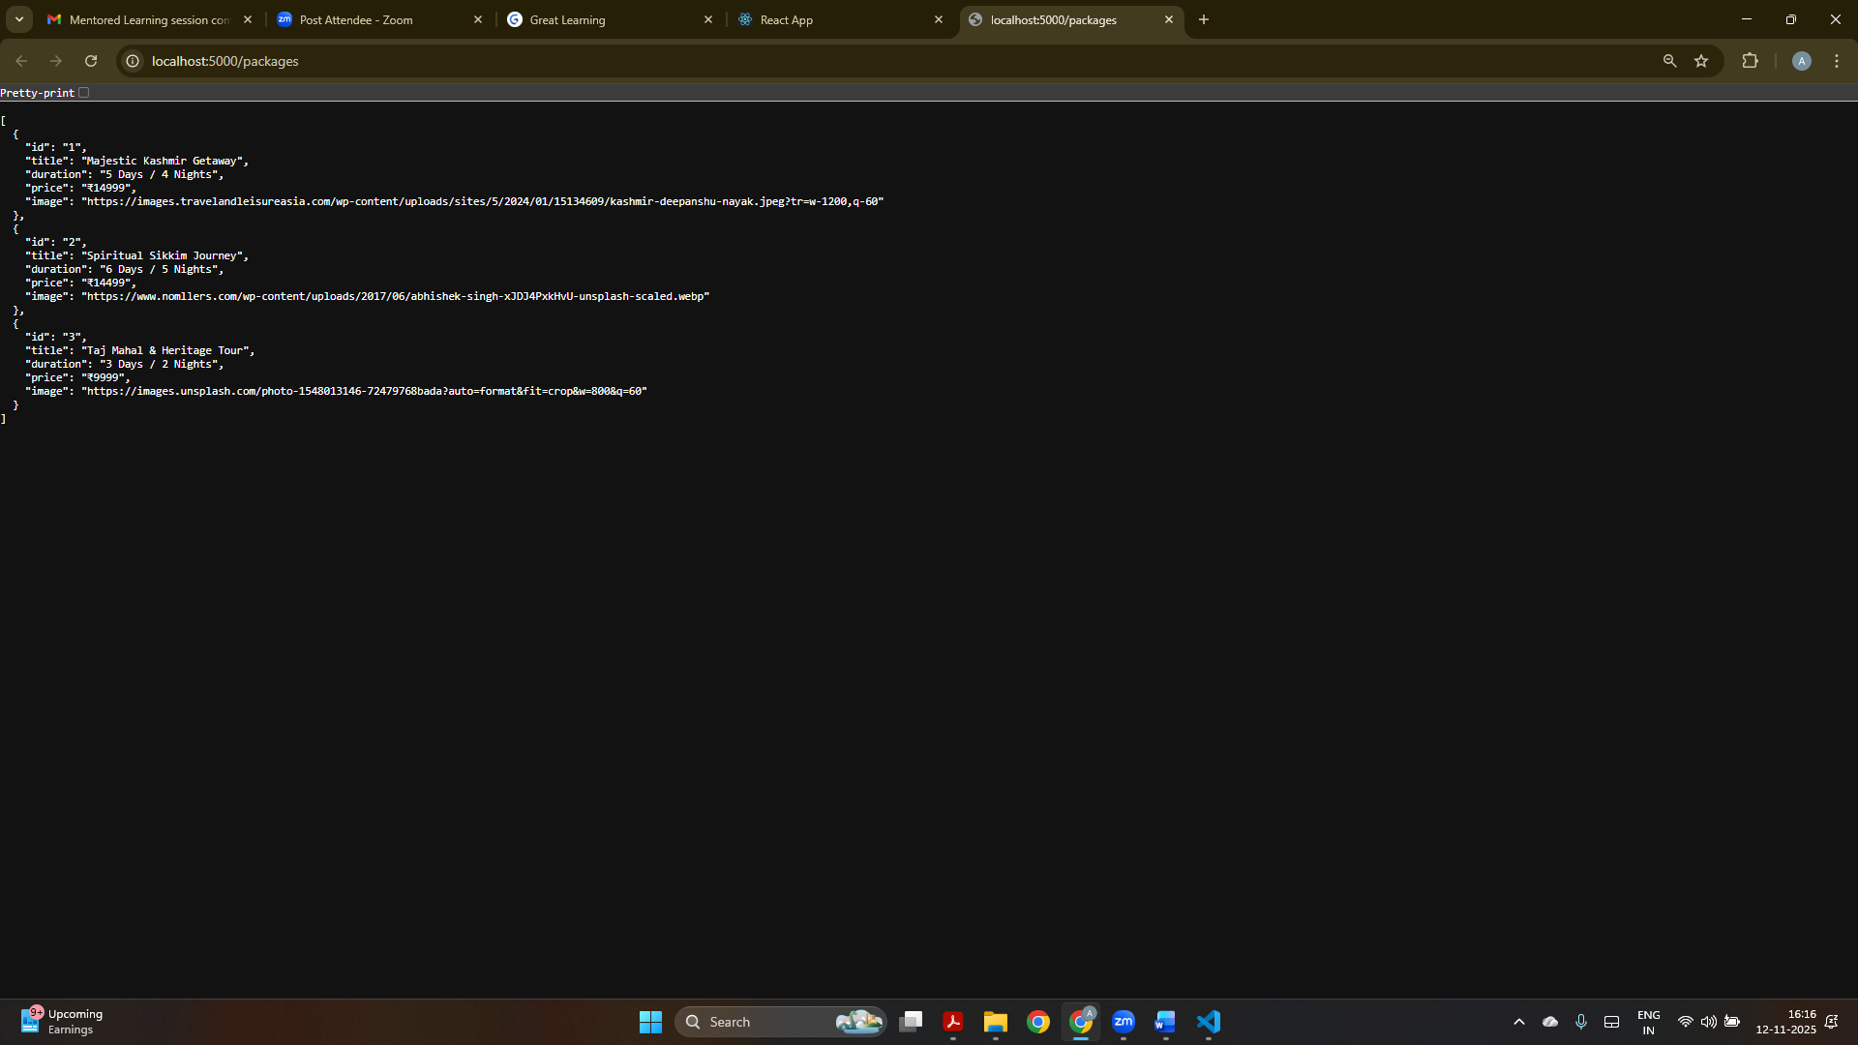
This is a temporary backend server whose data is fetched to show on the application.
User Story 3:
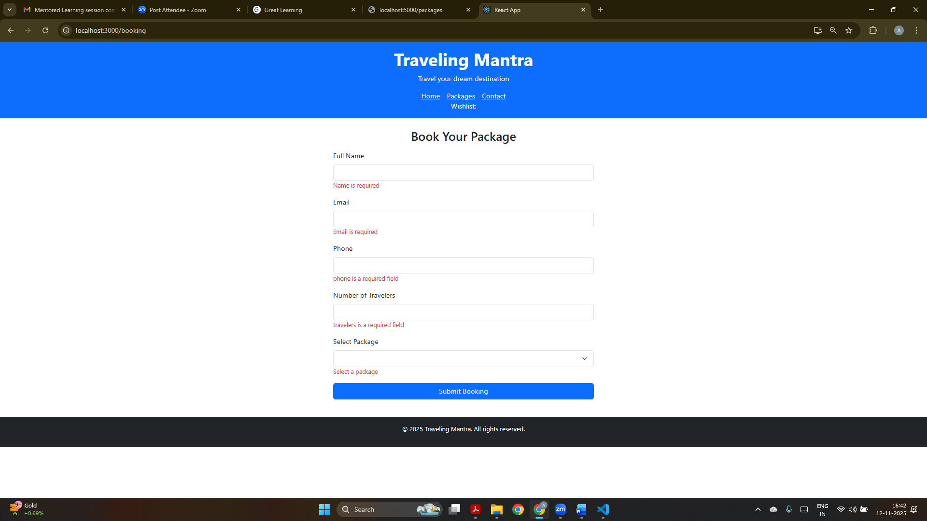
Here form validation is performed where we have to give specific types of data in the required field.

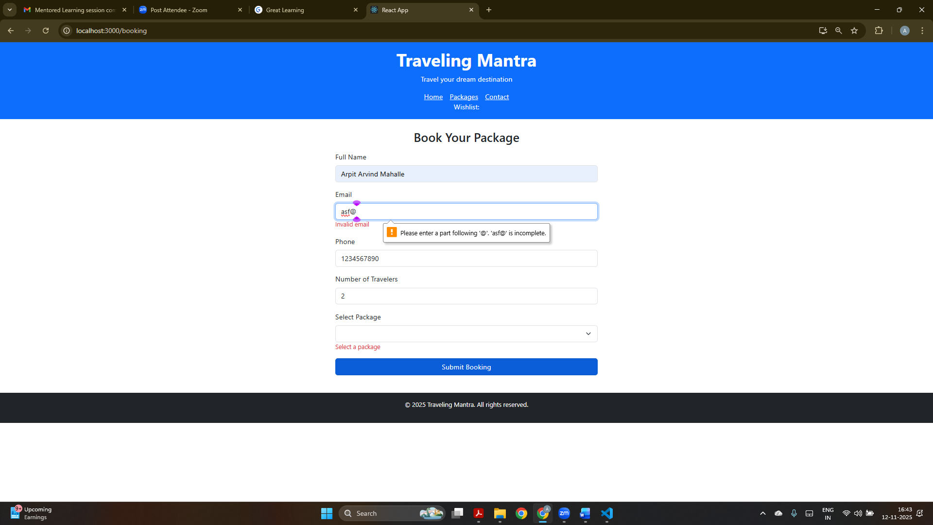
Here we have to input correct email address according to format such as abc@123.

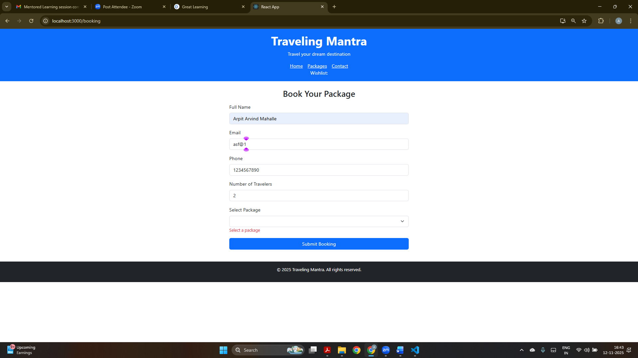
Here, package is not selected hence it will not be submitted.

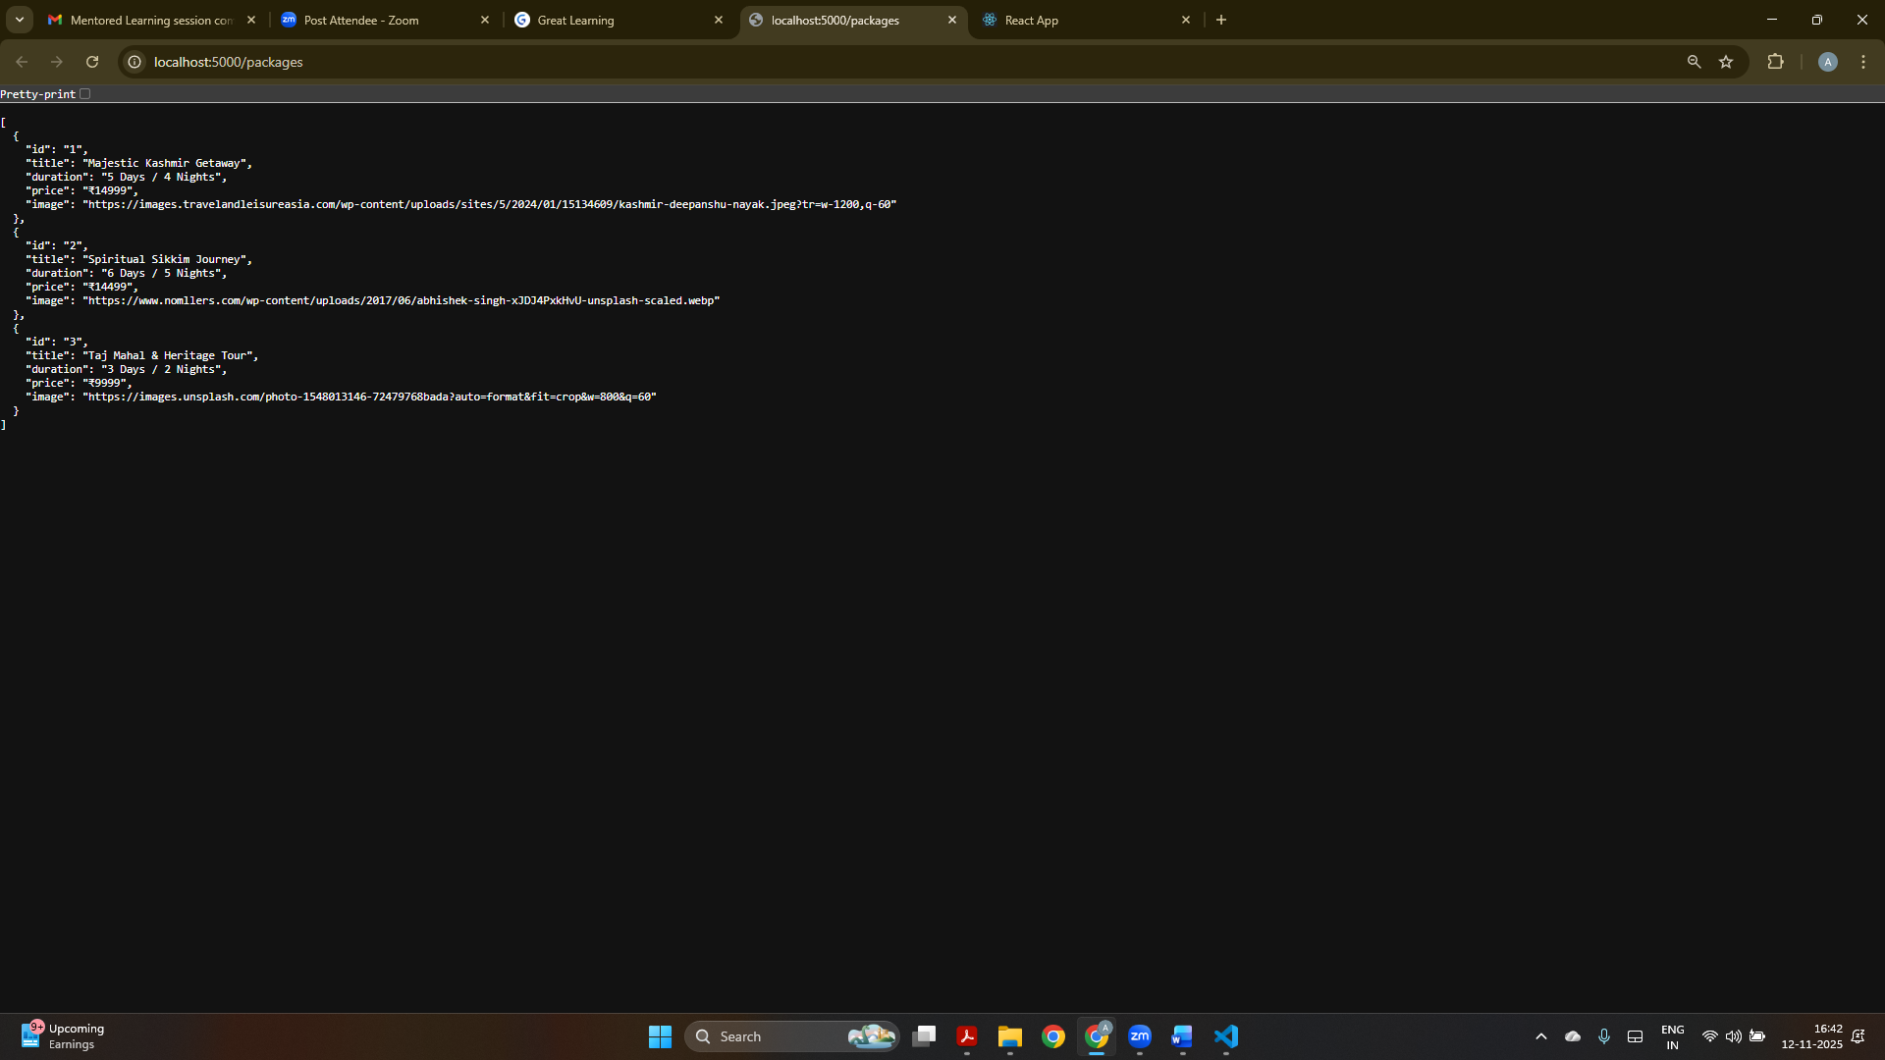
This is a temporary backend server whose data is fetched and shown in the application.

